This project has been funded with support from the European Commission. This publication reflects the views only of the author, and the Commission cannot be held responsible for any use which may be made of the information contained therein.

Fire and Emergency

Case study:
In this activity, based on an interactive virtual reality, students will work on how to proceed when the fire alarm goes off inside a building signalling evacuation.

Instructions for the teacher:

The case is based on the participants making the correct decisions in the different situations presented in order to reach the meeting point (the safe place where all staff and students should gather outside the building). Once participants have gone through the virtual situations they will discuss the reasons that led them to make their decisions and clarify any doubts that may have arisen.

In order to use the .swf file that includes this interactive virtual reality, you will need to download the swf (flashplayer) file viewer, available in different versions from the following URL

https://labs.adobe.com/downloads/flashplayer.html

The program viewer to open the swf file in Windows is the following:

https://fpdownload.macromedia.com/pub/labs/flashruntimes/flashplayer/flashplayer_29_sa.exe

When ready, the flashplayer file _______.exe (whichever version has been downloaded) will automatically run. You should choose File > Open from the options menu to select the correct file.

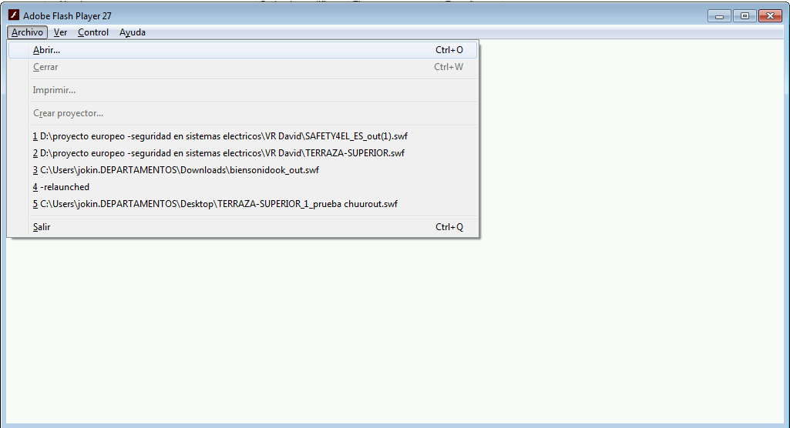

Session plan:
Participants need a computer with a .swf extension file viewer to take the virtual tour.

Instructions for participants: The main objective of the exercise is to leave the building safely and reach the meeting point. They may have to repeat part(s) of the experience if they make a wrong decision or give a wrong answer.

- You are invited to go through the following virtual reality experience recreating an emergency situation in which you need to evacuate safely during a fire
- Here’s the link to the swf file
- After the experience difficulties and doubts that have arisen during the activity will be discussed together.

Instructions for the teacher:

The lesson is based on the participants going through the virtual situations and making decisions in the different situations presented to them. At the end, they will discuss in a group the difficulties they have encountered to reach the right decisions; doubts that have arisen will also be clarified.

The situations that appear in the virtual reality are:

• In the scene with the legal warning, click on a red dot (the way the different options are presented in each scene) to move on to the next scene.
• In the workshop scene where fire has supposedly broken out, participants must find the exit; the emergency exit is indicated by a green sign.
• Before leaving the workshop, participants must choose to close the windows beforehand (this is the correct action to take before leaving a room in case of emergency); if they do not, they will return to the previous scene.
• Once participants have left the workshop they should follow the signs that indicate the correct evacuation route in case of emergency; in this case they shouldn’t get distracted or follow the person climbing the stairs (this option will take them back to the beginning). Instead they should follow the green signs indicating the established evacuation route.
• In the scene where there is a group of people in the corridor who don’t know what to do, the participant should instruct them to follow the signs indicating the evacuation route and not let them return to the workshop which they have just left.
• In the scene with three options to follow, the correct one is again the one indicated by the green evacuation sign; participants shouldn’t go down the stairs (as smoke can be seen in that direction) nor should they turn back.
•When the emergency exit has been reached, there is a quick general knowledge test about fire extinguishers, in which different types of fire must be linked with the corresponding color:
- Type A (green color): fires in which the combustible substance is solid (wood, cardboard ...)
- Type B (red color): fires in which the combustible is of liquid origin (oil, gasoline ...)
- Type C (blue color): fires in which the origin is gaseous (propane, butane ...).

• In the scene where you participants are on the fire stairs, they should choose to go down to proceed to the meeting point outside the building, not upstairs.
• Finally, the meeting point is reached outside the building and the activity is finished.

